Questions

**Q-1. Write an SQL query to fetch “FIRST_NAME” from Worker table using the alias name as <WORKER_NAME>.**

select first_name as worker_name from suman.workers

Output

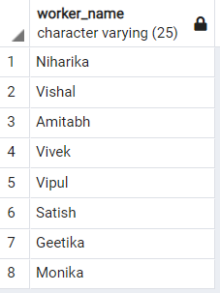

**Q-2. Write an SQL query to fetch “FIRST_NAME” from Worker table in upper case.**

select upper(first_name) as worker_name from suman.workers

Output

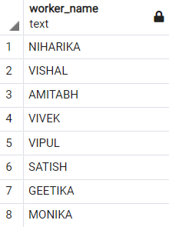

**Q-3. Write an SQL query to fetch unique values of DEPARTMENT from Worker table.**

select DISTINCT department from suman.workers

Output

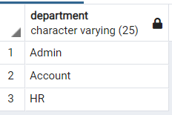

**Q-4. Write an SQL query to print the first three characters of  FIRST_NAME from Worker table.**

select SUBSTRING(first_name,1,3) from suman.workers

Output

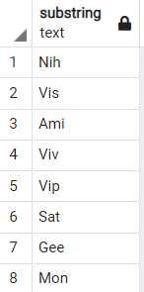

**Q-5. Write an SQL query to find the position of the alphabet (‘a’) in the first name column ‘Amitabh’ from Worker table.**

**Q-6. Write an SQL query to print the FIRST_NAME from Worker table after removing white spaces from the right side.**

SELECT RTRIM( first_name) from suman.workers

Output

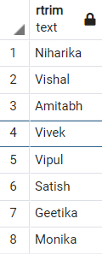

**Q-7. Write an SQL query to print the DEPARTMENT from Worker table after removing white spaces from the left side.**

SELECT LTRIM(department) from suman.workers

Output

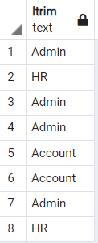

**Q-8. Write an SQL query that fetches the unique values of DEPARTMENT from Worker table and prints its length.**

SELECT DISTINCT length(department) from suman.workers

Output

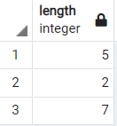

**Q-9. Write an SQL query to print the FIRST_NAME from Worker table after replacing ‘a’ with ‘A’.**

SELECT replace(first_name,'a','A') from suman.workers

Output

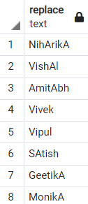

**Q-10. Write an SQL query to print the FIRST_NAME and LAST_NAME from Worker table into a single column COMPLETE_NAME. A space char should separate them.**

select concat (first_name, last_name) as complete_name from suman.workers

Output

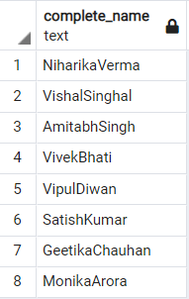

**Q-11. Write an SQL query to print all Worker details from the Worker table order by FIRST_NAME Ascending.**

select first_name from suman.workers order by first_name asc

Output

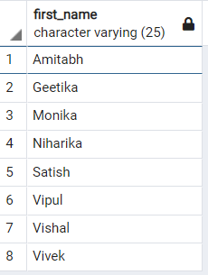

**Q-12. Write an SQL query to print all Worker details from the Worker table order by FIRST_NAME Ascending and DEPARTMENT Descending.**

select * from suman.workers order by first_name asc, department desc

Output

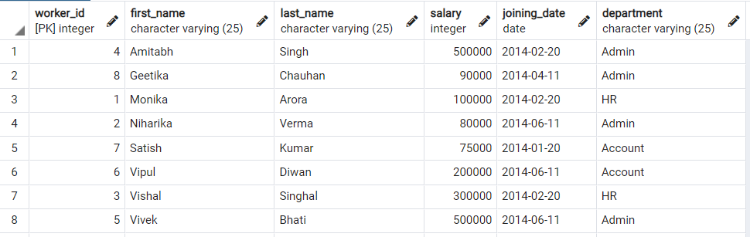

**Q-13. Write an SQL query to print details for Workers with the first name as “Vipul” and “Satish” from Worker table.**

SELECT first_name from suman.workers where first_name in ('Vipul','Satish')

Output

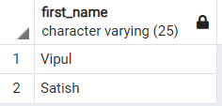

**Q-14. Write an SQL query to print details of workers excluding first names, “Vipul” and “Satish” from Worker table.**

SELECT * from suman.workers except SELECT * from suman.workers where first_name in ('Vipul','Satish')

Output

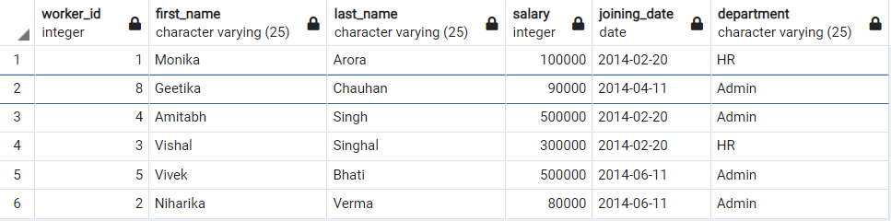

**Q-15. Write an SQL query to print details of Workers with DEPARTMENT name as “Admin”.**

select * FROM suman.workers where workers.department='Admin'

Output



**Q-16. Write an SQL query to print details of the Workers whose FIRST_NAME contains ‘a’.**

select * from suman.workers where first_name like '%a%'

Output

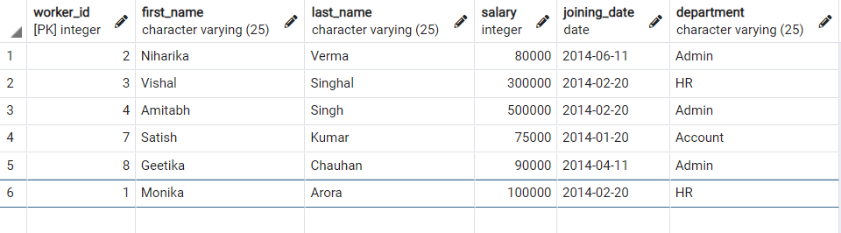

**Q-17. Write an SQL query to print details of the Workers whose FIRST_NAME ends with ‘a’.**

select * from suman.workers where first_name like '%a'

Output

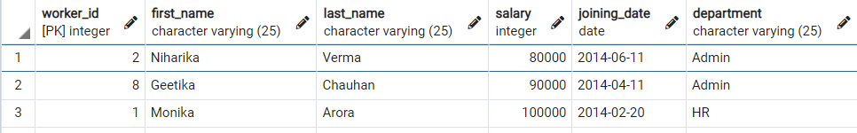

**Q-18. Write an SQL query to print details of the Workers whose FIRST_NAME ends with ‘h’ and contains six alphabets.**

select * from suman.workers where first_name like '%h' and length(first_name)=6

output

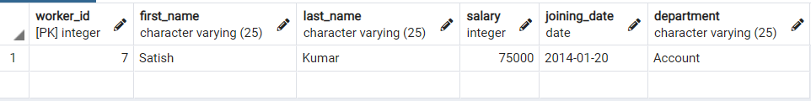

**Q-19. Write an SQL query to print details of the Workers whose SALARY lies between 100000 and 500000.**

select * from suman.workers where salary BETWEEN '100000' and '500000'

Output

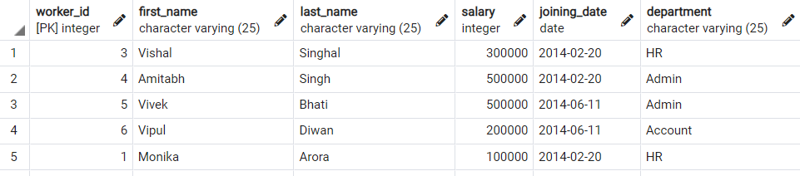

**Q-20. Write an SQL query to print details of the Workers who have joined in Feb’2014.**

Select * from suman.Workers where EXTRACT(ISOYEAR FROM JOINING_DATE) = 2014 and EXTRACT(MONTH FROM JOINING_DATE) = 2;

Output

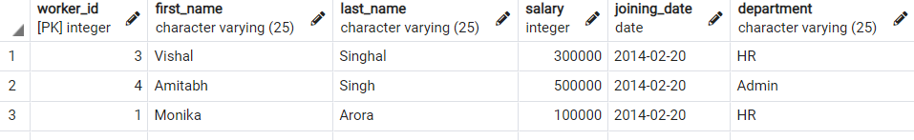

**Q-21. Write an SQL query to fetch the count of employees working in the department ‘Admin’.**

select count(first_name) from suman.workers where department='Admin'

Output

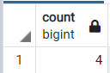

**Q-22. Write an SQL query to fetch worker names with salaries >= 50000 and <= 100000.**

select first_name from suman.workers where salary >= 50000 and salary<= 100000

Output

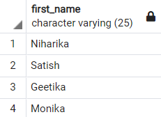

**Q-23. Write an SQL query to fetch the no. of workers for each department in the descending order.**

select count(first_name),department from suman.workers group by department

Output

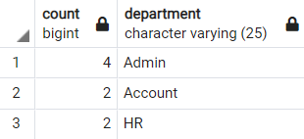

**Q-24. Write an SQL query to print details of the Workers who are also Managers.**

SELECT * FROM suman.workers as w INNER JOIN suman.title as ti ON w.worker_id= ti.worker_ref_id where ti.worker_title ='Manager'

Output



**Q-25. Write an SQL query to fetch duplicate records having matching data in some fields of a table.**

SELECT WORKER_TITLE, AFFECTED_FROM, COUNT(*) FROM suman.title GROUP BY WORKER_TITLE, AFFECTED_FROM HAVING COUNT(*) > 1;

Output

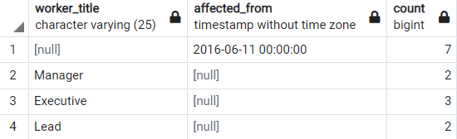

**Q-26. Write an SQL query to show only odd rows from a table.**

SELECT * FROM suman.Workers WHERE MOD (WORKER_ID, 2) <> 0;

Output

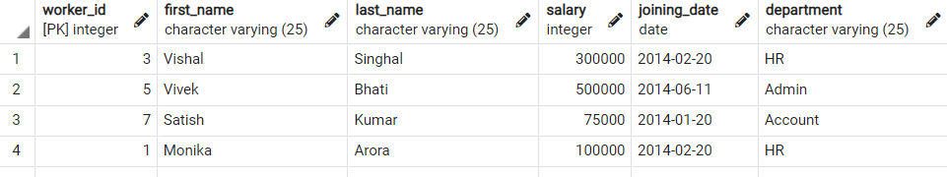

**Q-27. Write an SQL query to show only even rows from a table.**

SELECT * FROM suman.Workers WHERE MOD (WORKER_ID, 2) = 0;

Output

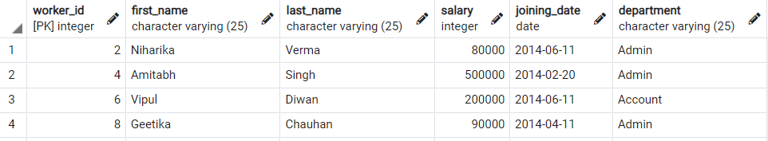

**Q-28. Write an SQL query to clone a new table from another table.**

CREATE TABLE suman.clone_table as TABLE suman.workers

**Q-29. Write an SQL query to fetch intersecting records of two tables.**

select worker_id from suman.workers INTERSECT select bonus.worker_ref_id from suman.bonus

Output

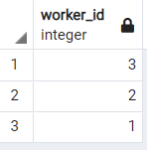

**Q-30. Write an SQL query to show records from one table that another table does not have.**

SELECT W.worker_id,W.first_name,W.last_name,W.salary,W.joining_date,W.department FROM suman.workers w,(SELECT worker_id FROM suman.Workers EXCEPT SELECT worker_ref_id FROM suman.Bonus) B WHERE W.worker_id = B.worker_id ;

Output

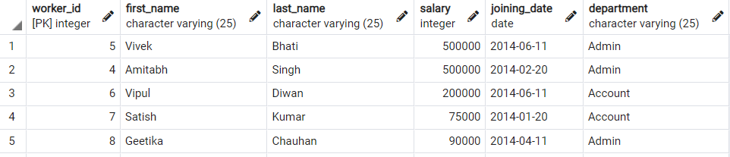

**Q-31. Write an SQL query to show the current date and time.**

select now();

Output

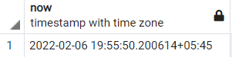

**Q-32. Write an SQL query to show the top n (say 10) records of a table.**

SELECT * FROM suman.Workers ORDER BY Last_name ASC LIMIT 10;

Output

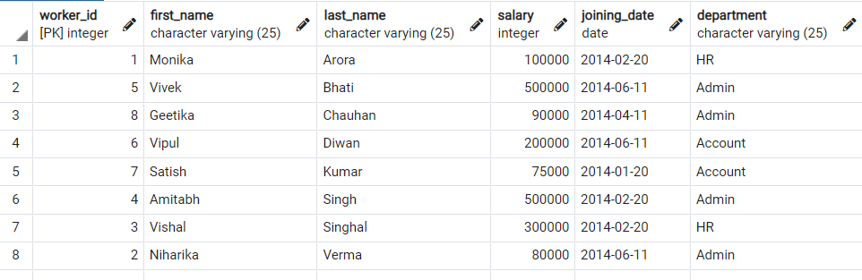

**Q-33. Write an SQL query to determine the nth (say n=5) highest salary from a table.**

SELECT Salary FROM suman.Workers ORDER BY Salary DESC LIMIT 1;

Output

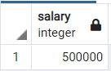

**Q-34. Write an SQL query to determine the 5th highest salary without using TOP or limit method.**

SELECT Salary FROM suman.Workers W1 WHERE 4 = (SELECT COUNT( DISTINCT ( W2.Salary ) ) FROM suman.Workers W2 WHERE W2.Salary >= W1.Salary )

Output

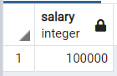

**Q-35. Write an SQL query to fetch the list of employees with the same salary.**

Select distinct W.WORKER_ID, W.FIRST_NAME, W.Salary from suman.Workers W, suman.Workers W1 where W.Salary = W1.Salary and W.WORKER_ID != W1.WORKER_ID;

Output

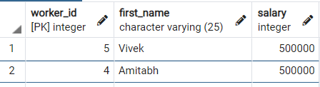

**Q-36. Write an SQL query to show the second highest salary from a table.**

Select max(Salary) from suman.Workers where Salary not in (Select max(Salary) from suman.Workers)

Output

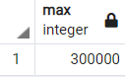

**Q-37. Write an SQL query to show one row twice in results from a table.**

select * from suman.Workers W where W.DEPARTMENT='Admin'

union all

select * from suman.Workers W1 where W1.DEPARTMENT='Admin'

Output

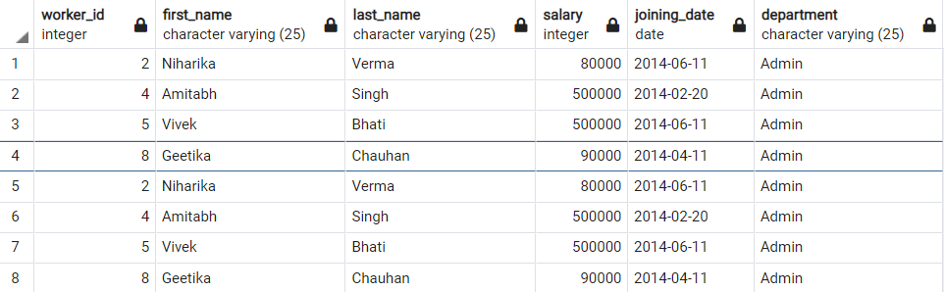

**Q-38. Write an SQL query to fetch intersecting records of two tables.**

(SELECT * FROM suman.Workers) INTERSECT (SELECT * FROM suman.clone_table)

Output

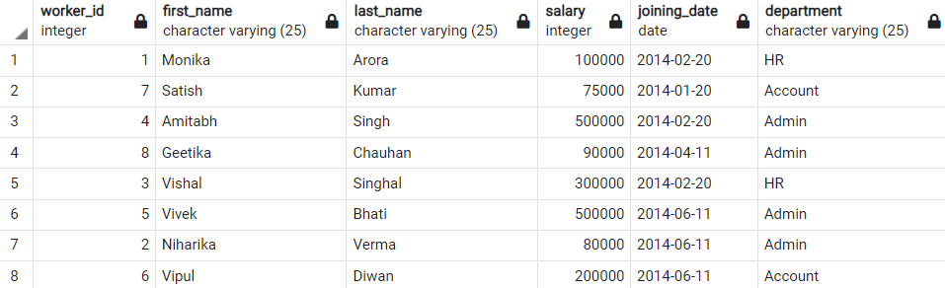

**Q-39. Write an SQL query to fetch the first 50% records from a table.**

SELECT * FROM suman.WORKERS WHERE WORKER_ID <= (SELECT count(WORKER_ID)/2 from suman.Workers)

Output

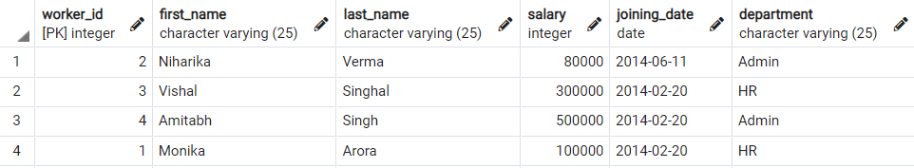

**Q-40. Write an SQL query to fetch the departments that have less than five people in it.**

SELECT DEPARTMENT, COUNT(WORKER_ID) as Number_of_Workers FROM suman.Workers GROUP BY DEPARTMENT HAVING COUNT(WORKER_ID) < 5

Output

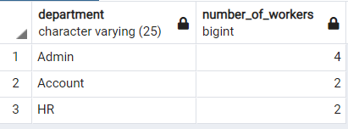

**Q-41. Write an SQL query to show all departments along with the number of people in there.**

SELECT DEPARTMENT, COUNT(DEPARTMENT) as Number_of_Workers FROM suman.Workers GROUP BY DEPARTMENT

Output

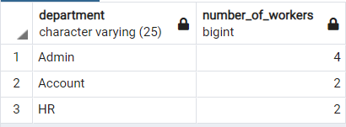

**Q-42. Write an SQL query to show the last record from a table.**

Select * from suman.Workers where WORKER_ID = (SELECT max(WORKER_ID) from suman.Workers)

Output



**Q-43. Write an SQL query to fetch the first row of a table.**

Select * from suman.Workers where WORKER_ID = (SELECT min(WORKER_ID) from suman.Workers)

Output



**Q-44. Write an SQL query to fetch the last five records from a table.**

SELECT * FROM suman.Workers WHERE WORKER_ID <=5

UNION

SELECT * FROM (SELECT * FROM suman.Workers W order by W.WORKER_ID ASC) AS W1 WHERE W1.WORKER_ID <=5

Output

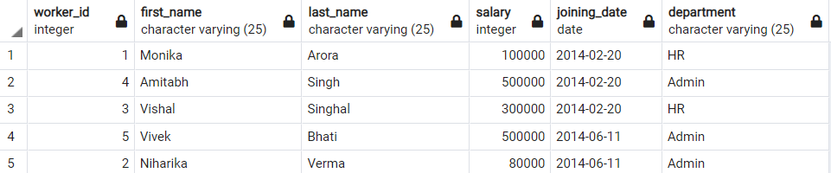

**Q-45. Write an SQL query to print the name of employees having the highest salary in each department.**

SELECT t.DEPARTMENT,t.FIRST_NAME,t.Salary from(SELECT max(Salary) as TotalSalary,DEPARTMENT from suman.Workers group by DEPARTMENT) as TempNew

Inner Join suman.Workers t on TempNew.DEPARTMENT=t.DEPARTMENT

and TempNew.TotalSalary=t.Salary

Output

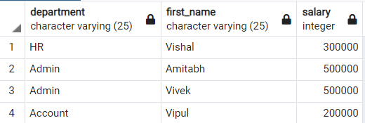

**Q-46. Write an SQL query to fetch three max salaries from a table.**

SELECT distinct Salary from suman.workers a WHERE 3 >= (SELECT count(distinct Salary) from suman.workers b WHERE a.Salary <= b.Salary) order by a.Salary desc

Output

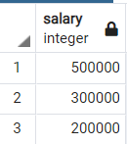

**Q-47. Write an SQL query to fetch three min salaries from a table.**

SELECT distinct Salary from suman.workers a WHERE 3 >= (SELECT count(distinct Salary) from suman.workers b WHERE a.Salary >= b.Salary) order by a.Salary desc

Output

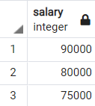

**Q-48. Write an SQL query to fetch nth max salaries from a table.**

SELECT distinct Salary from suman.workers a WHERE 8 >= (SELECT count(distinct Salary) from suman.workers b WHERE a.Salary <= b.Salary) order by a.Salary desc

Output

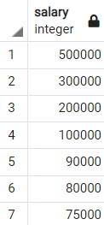

**Q-49. Write an SQL query to fetch departments along with the total salaries paid for each of them.**

SELECT DEPARTMENT, sum(Salary) from suman.workers group by DEPARTMENT

Output

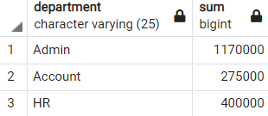

**Q-50. Write an SQL query to fetch the names of workers who earn the highest salary.**

SELECT FIRST_NAME, SALARY from suman.Workers WHERE SALARY=(SELECT max(SALARY) from suman.Workers)

Output

